Tasks 1:

Power on devices and then configure the devices as follows:

1) Configure IP addresses as shown in the diagram

2) Ensure routers can ping each other

3) Configure an enable password of "cisco"

4) Encrypt the enable password

5) Configure a secret password of "cisco123"

6) Configure the first 5 telnet lines and use a line password of cisco on them

7) Make sure you can telnet from one device to the other

8) Configure a console password of "cisco" and test

Task 2:

Do the initial configuration of a Router

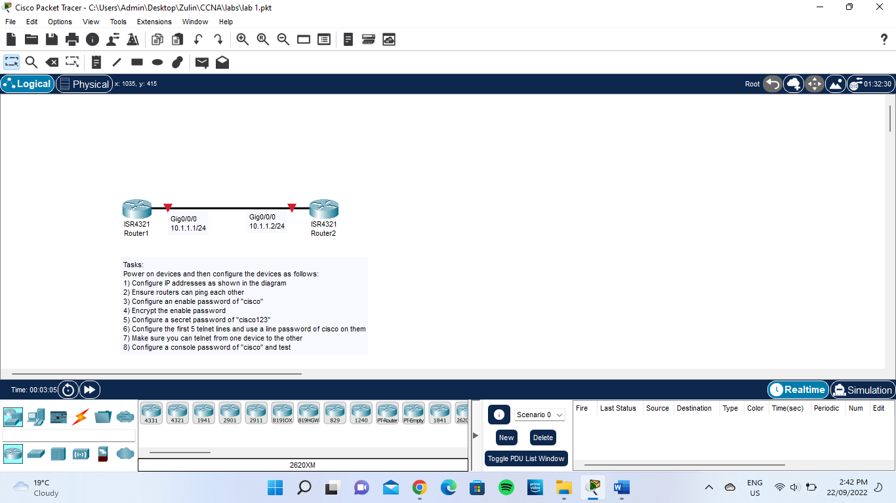

1. Configure IP addresses as shown in the diagram

**Router 1**

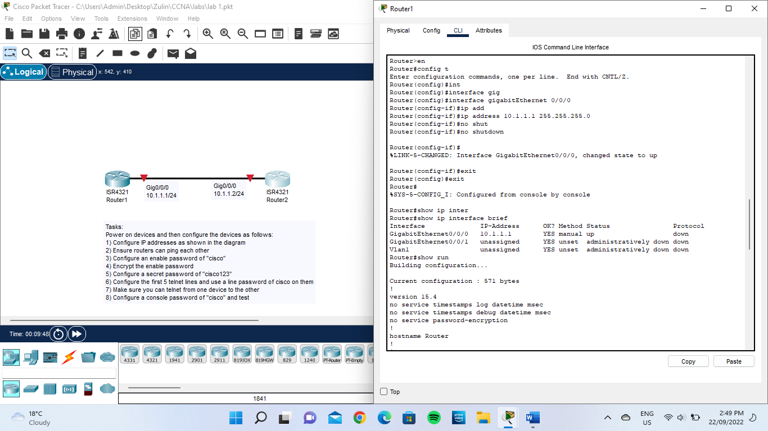

**Router 2**

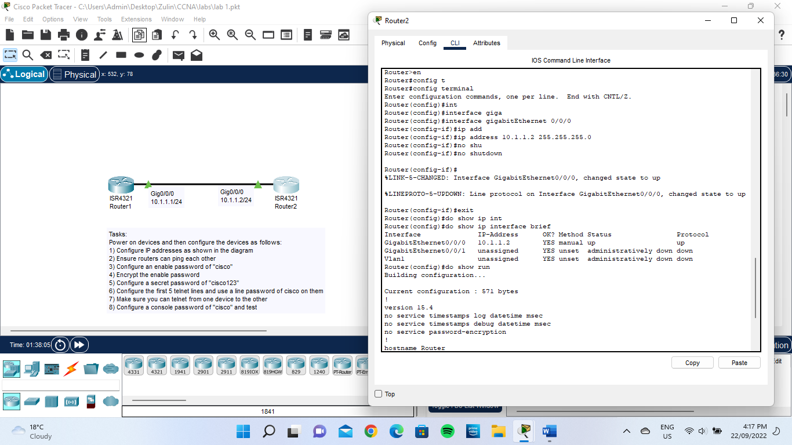

2) Ensure routers can ping each other

**Router 1**

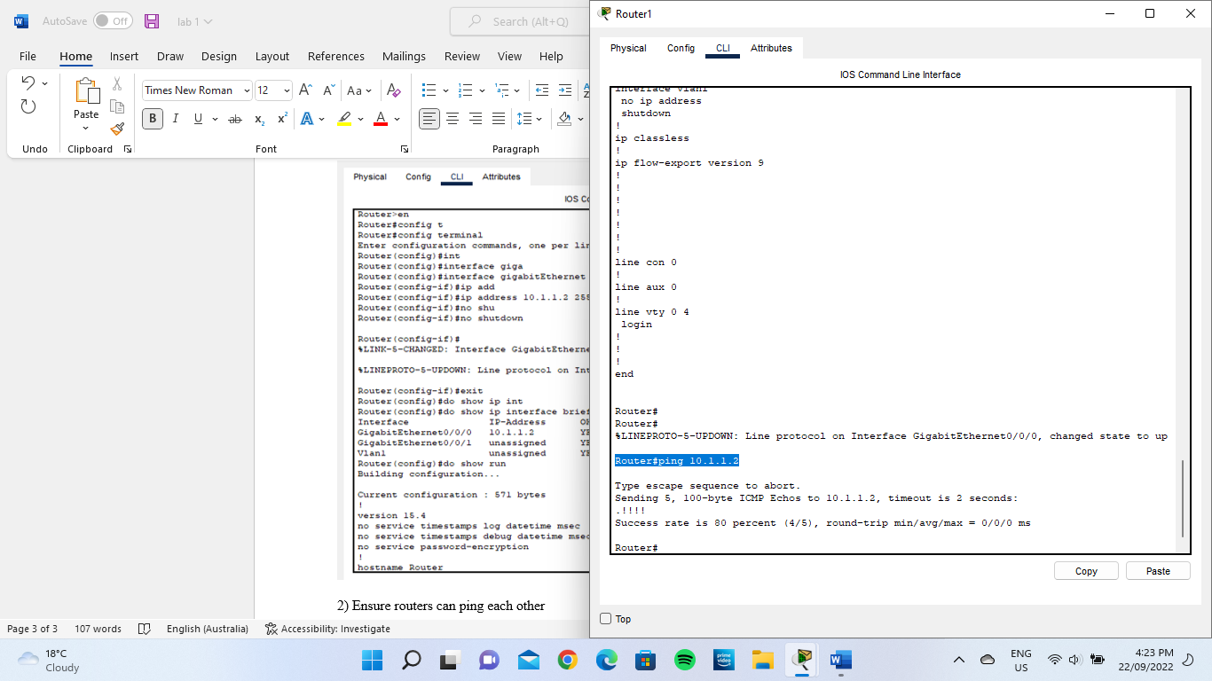

**Router 2**

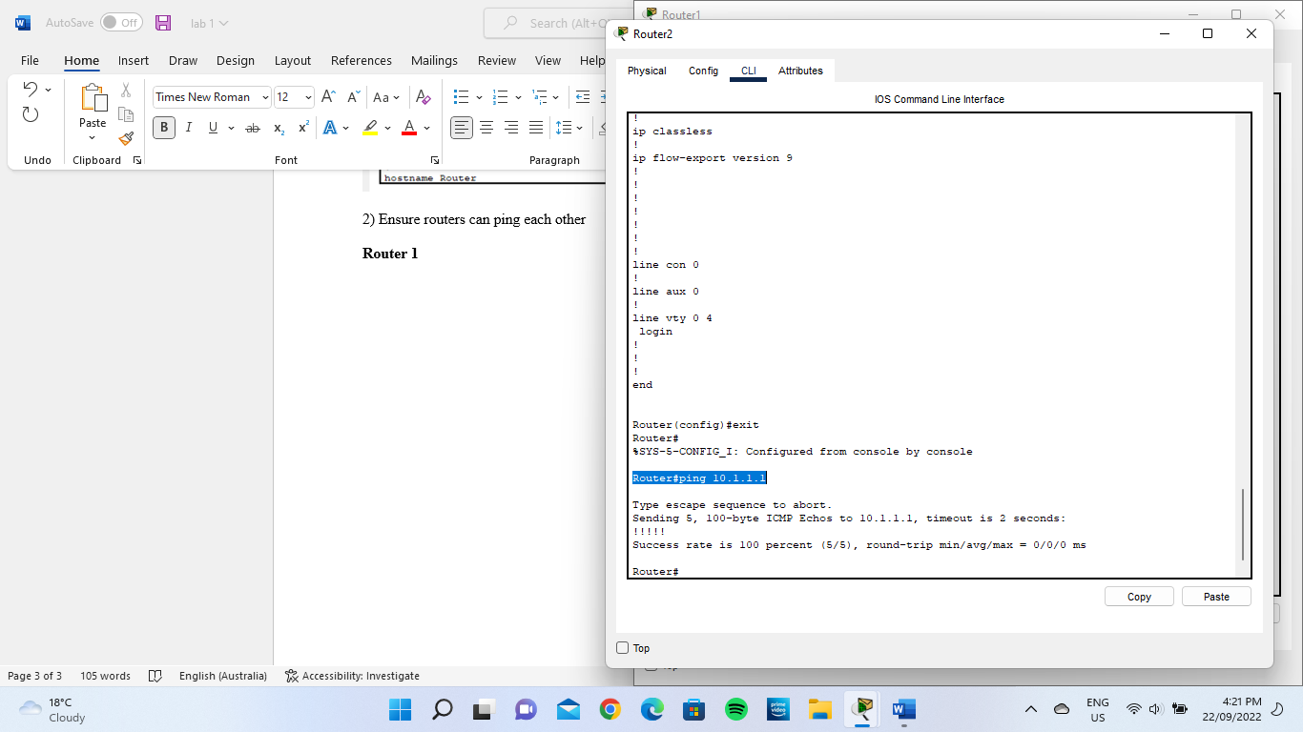

1. Configure an enable password of "cisco"

**Router 1**

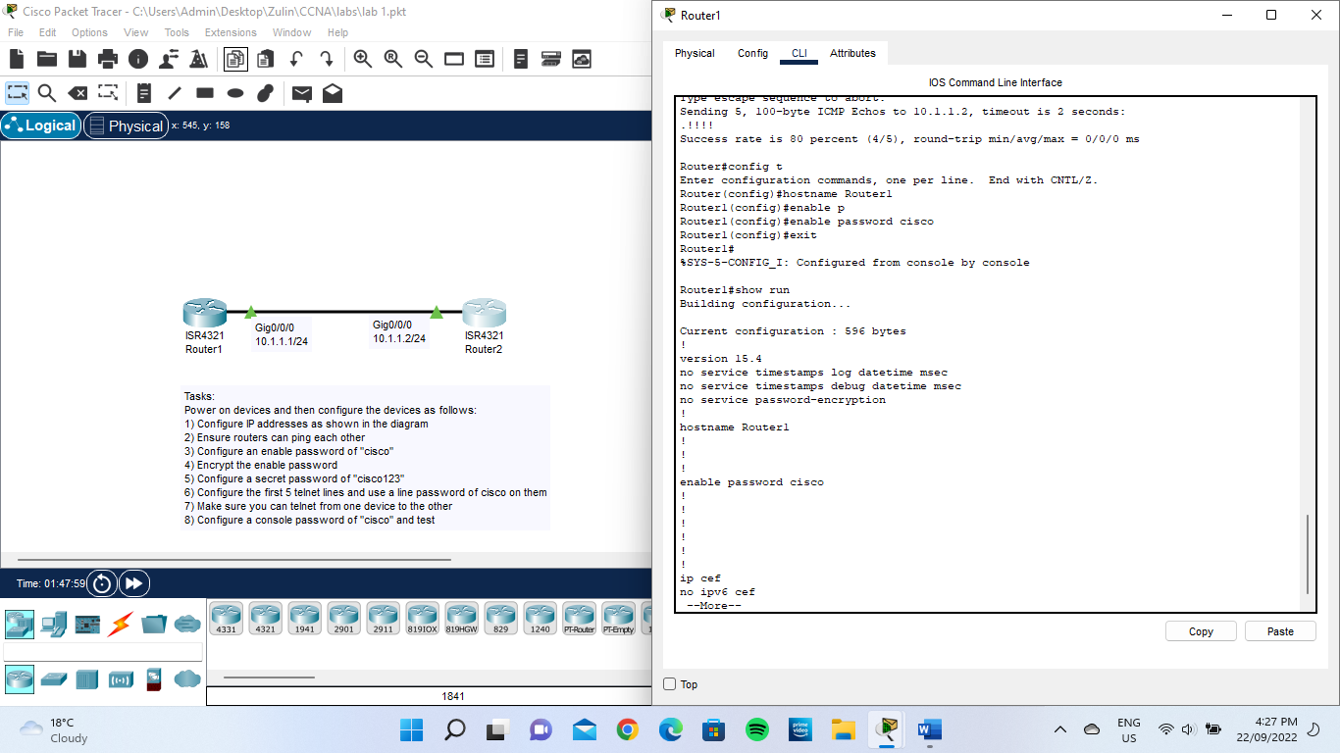

Router1>en

Password:

Router1#

**Router 2**

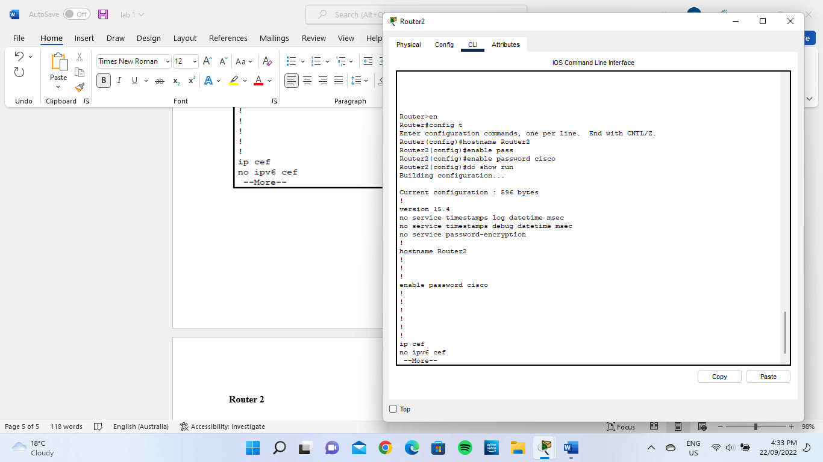

Router2>en

Password:

Router2#

4) Encrypt the enable password

**Router 1**

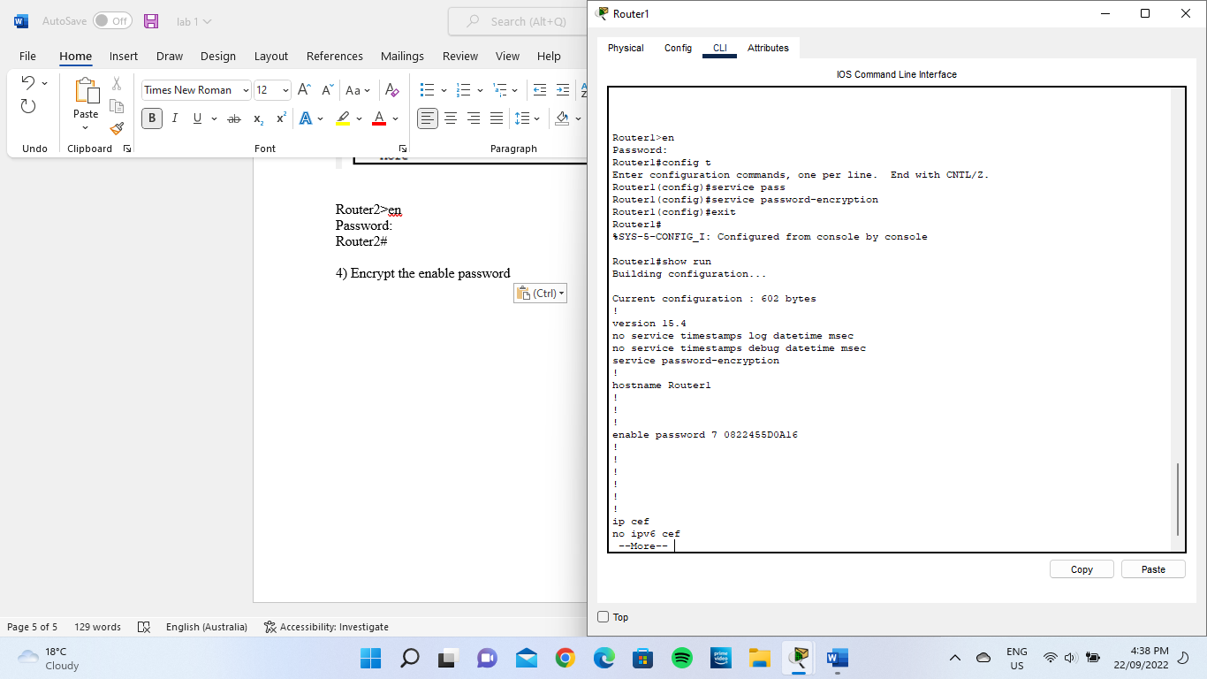

**Router 2**

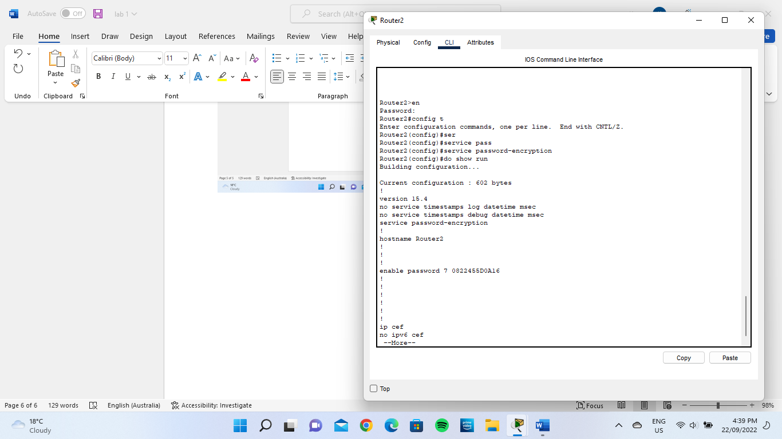

5) Configure a secret password of "cisco123"

**Router 1**

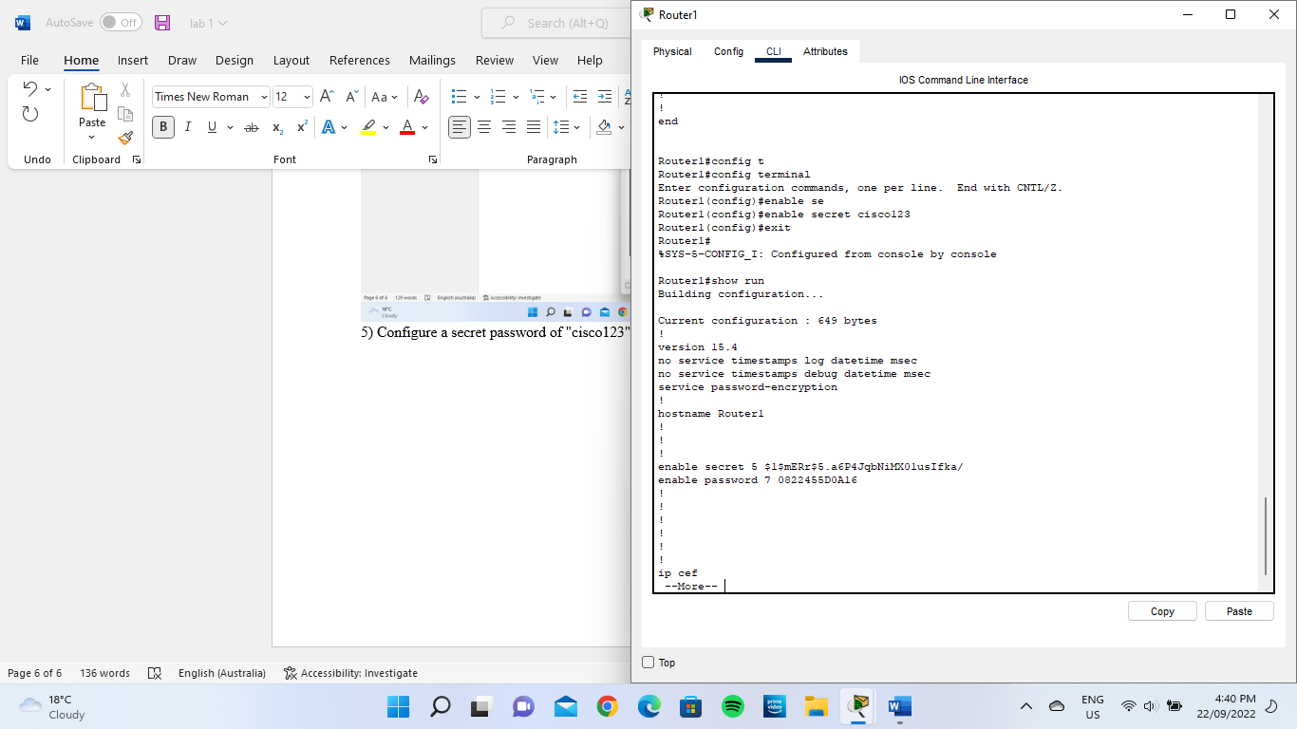

**Router 2**

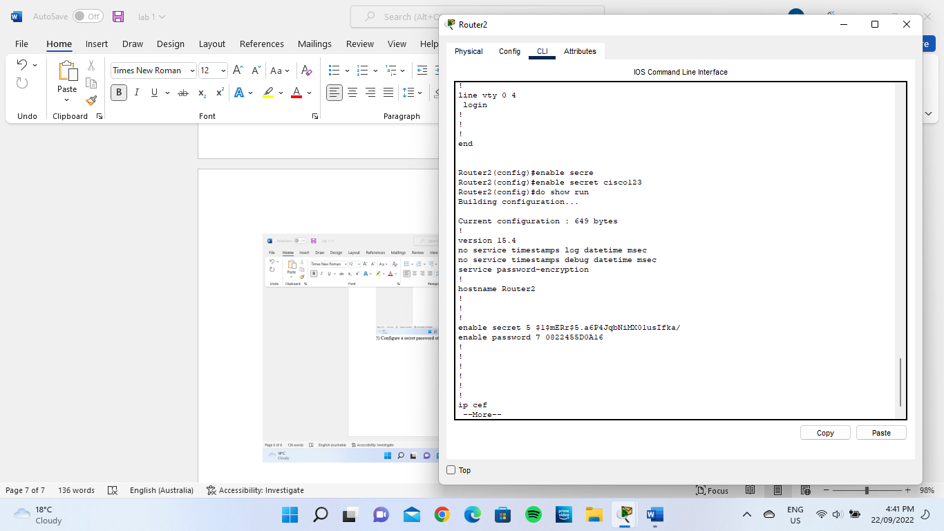

6) Configure the first 5 telnet lines and use a line password of cisco on them

7) Make sure you can telnet from one device to the other

**Router 1**

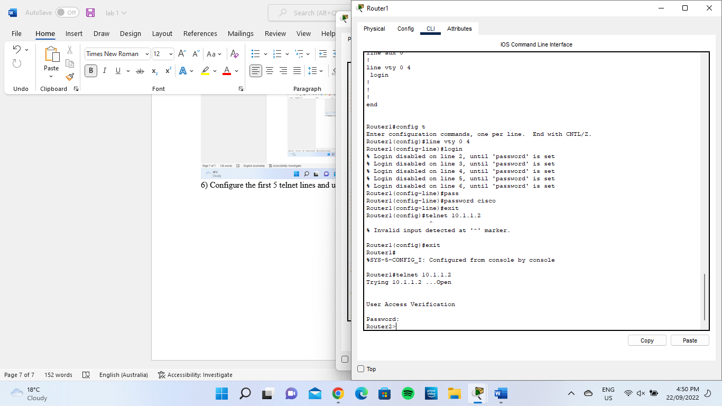

**Router 2**

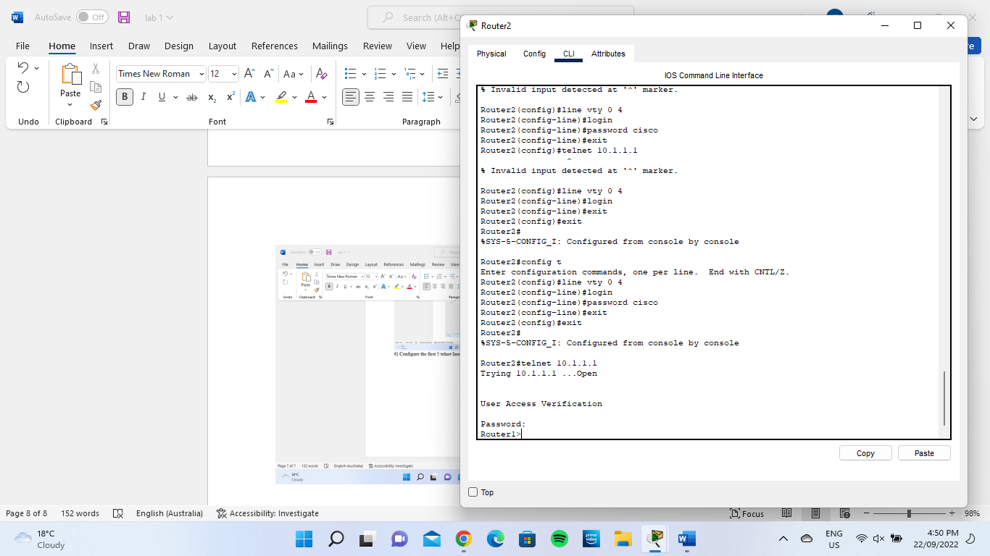

8) Configure a console password of "cisco" and test

**Router 1**

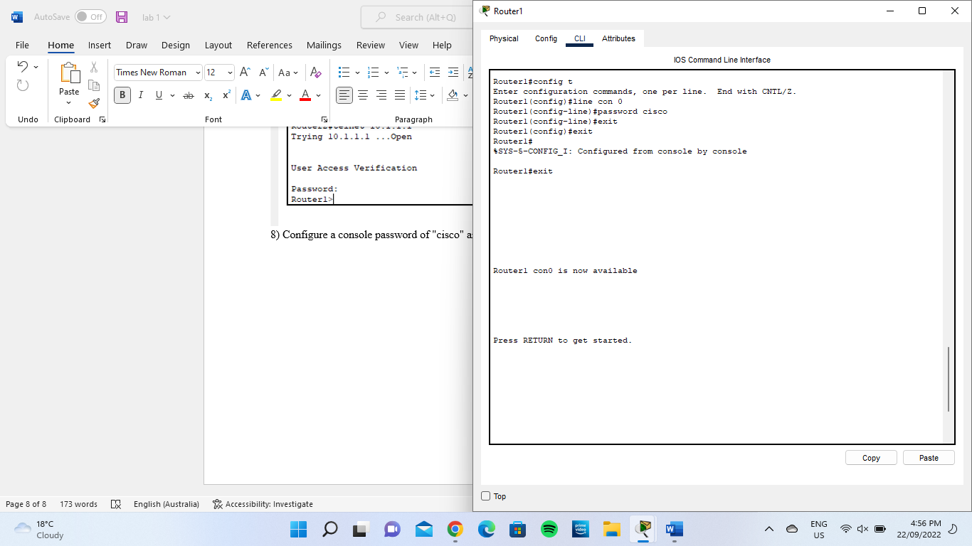

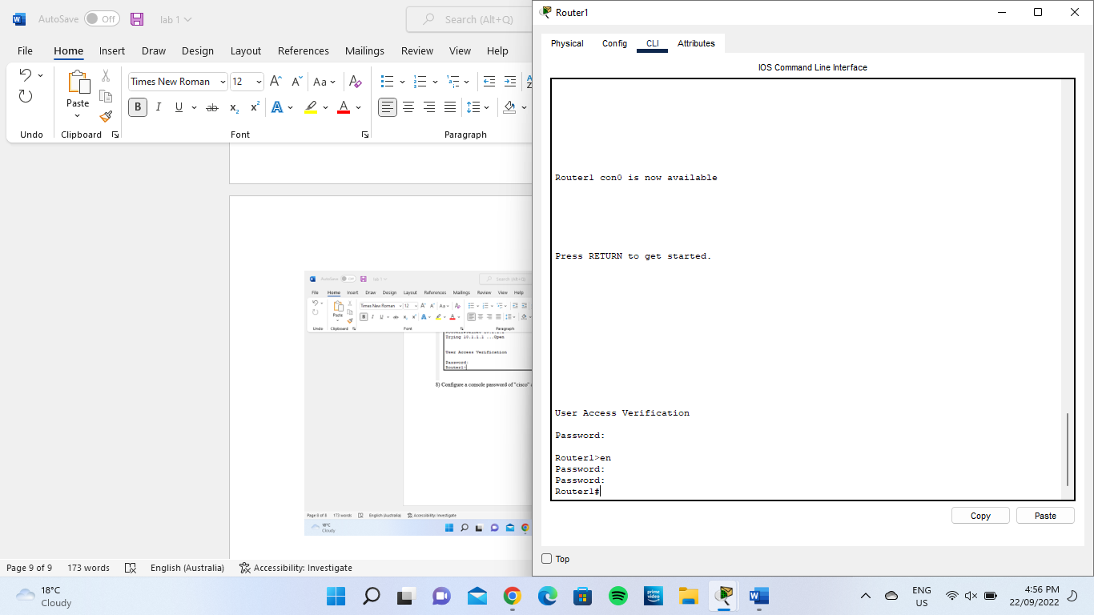

**Router 2**

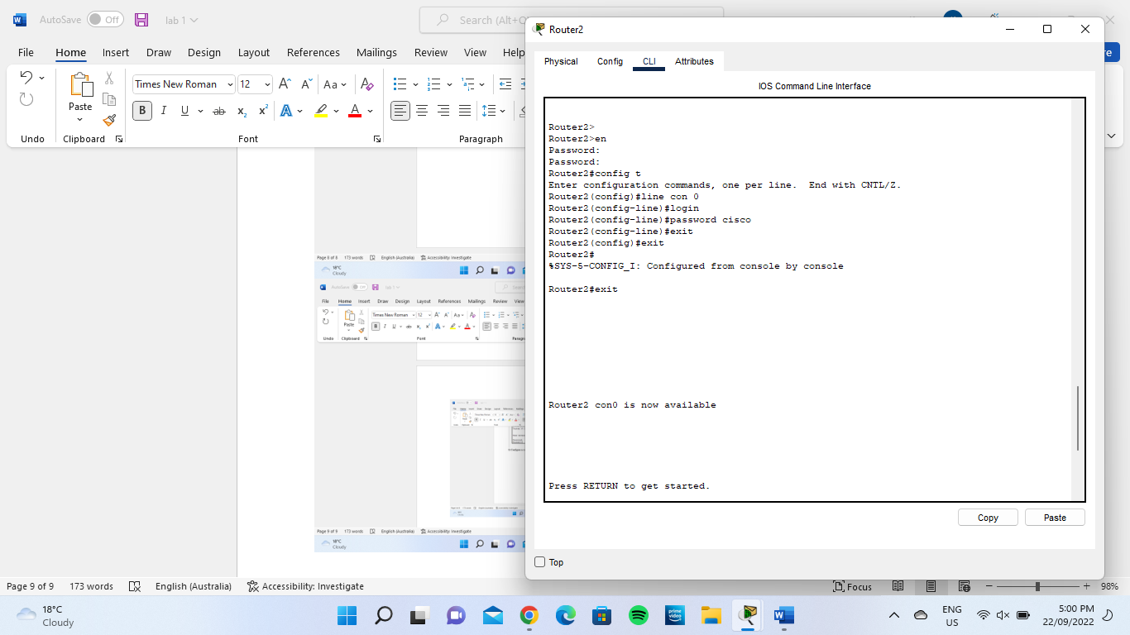

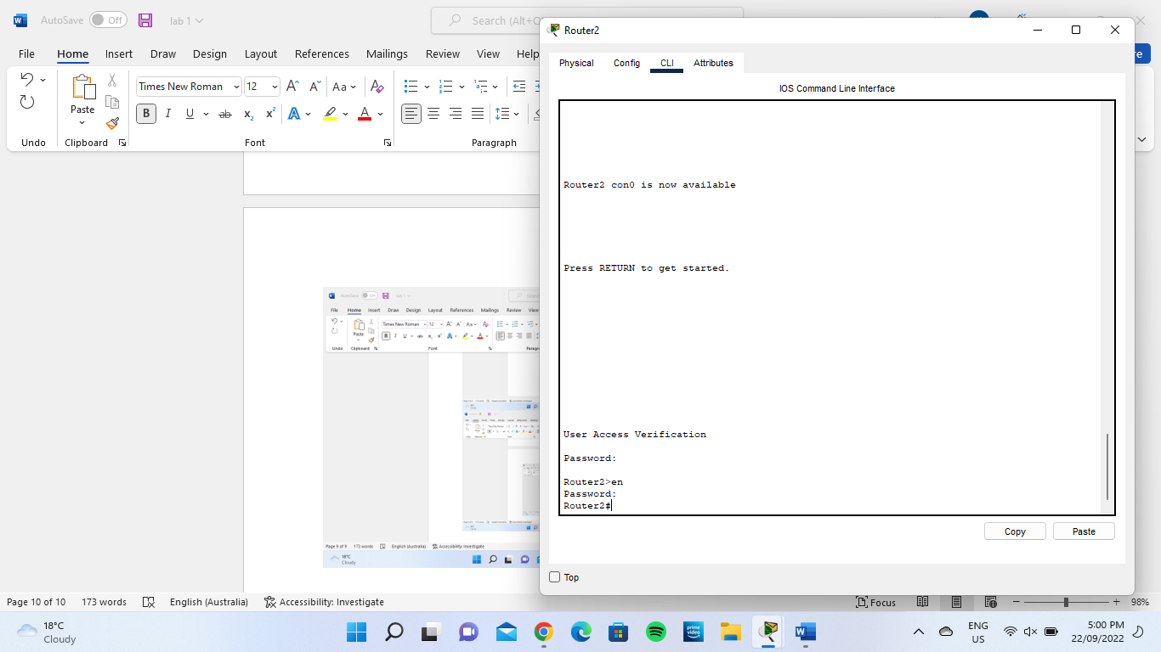

**All configurations are done**

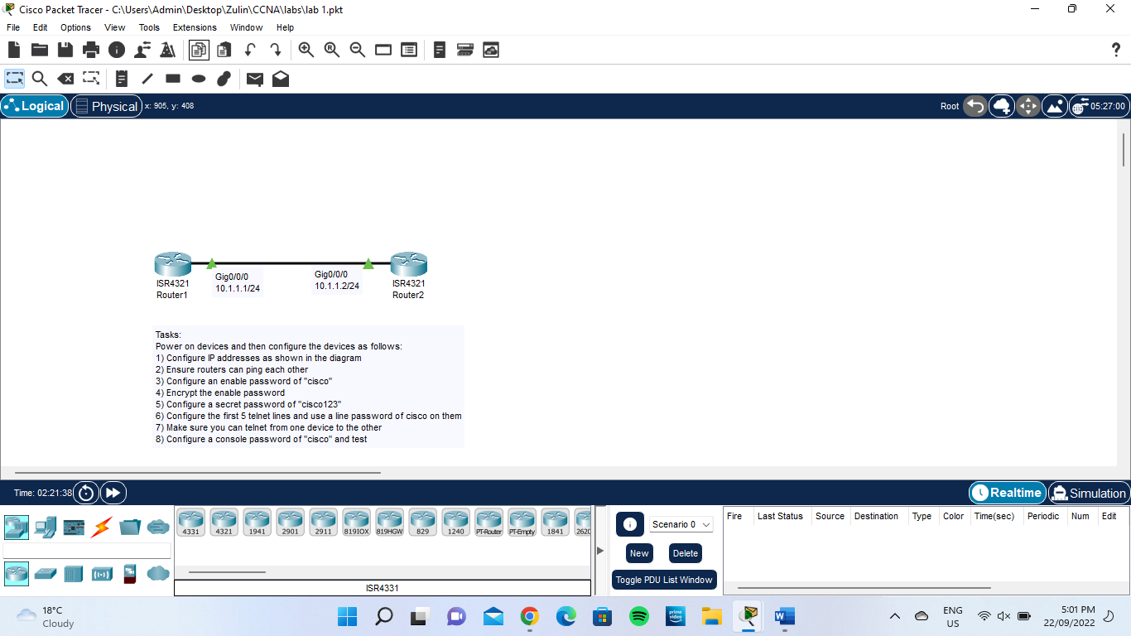

* Let’s check the running config and start-up config:

As I didn’t configure the router in the starting, startup-config is not present

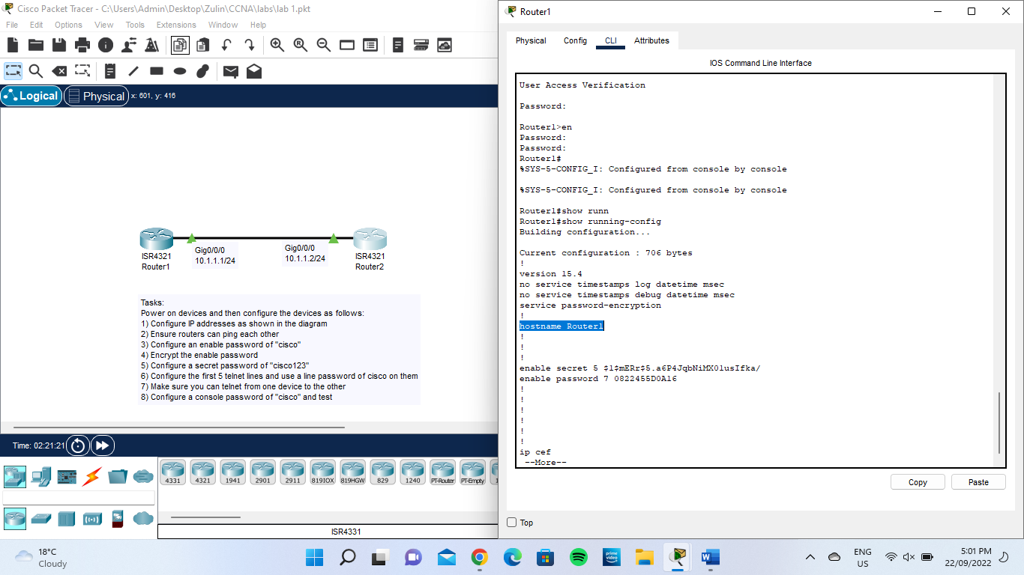

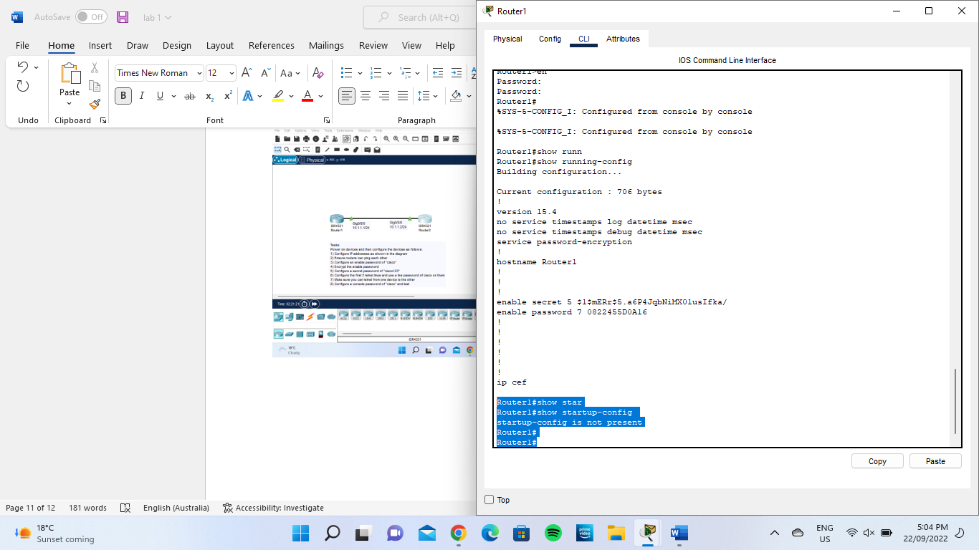

* **Copy running config in start-up config**

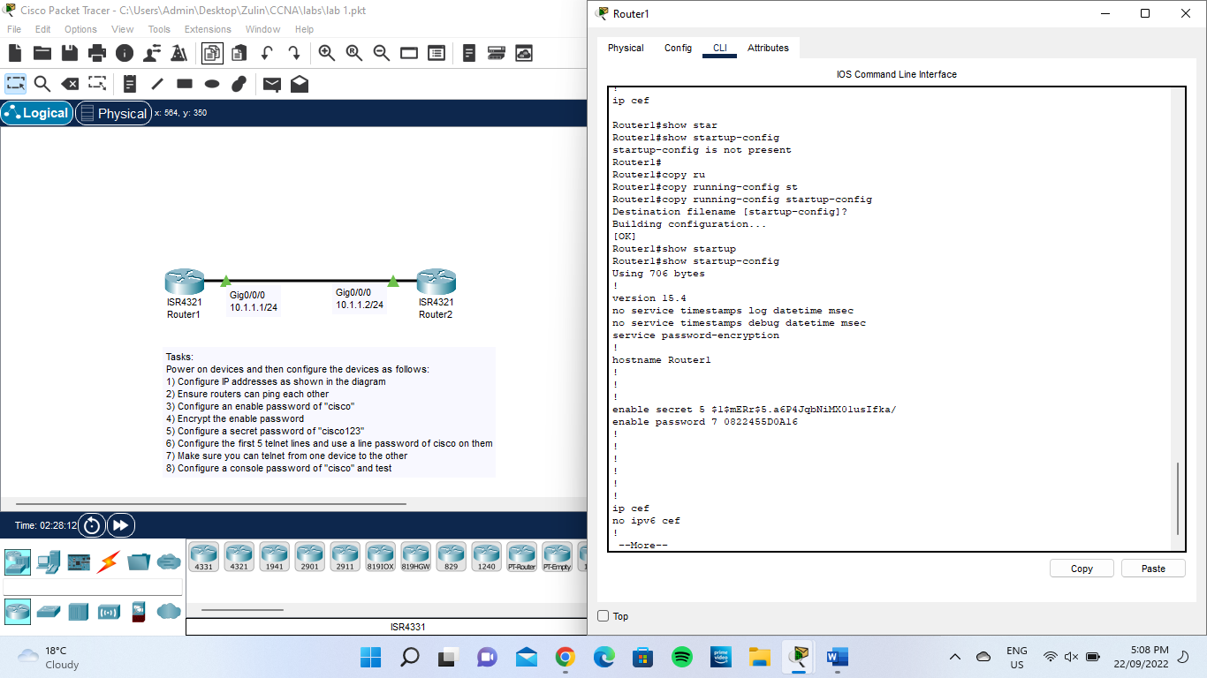

**Task 2:** Do the initial configuration of a Router

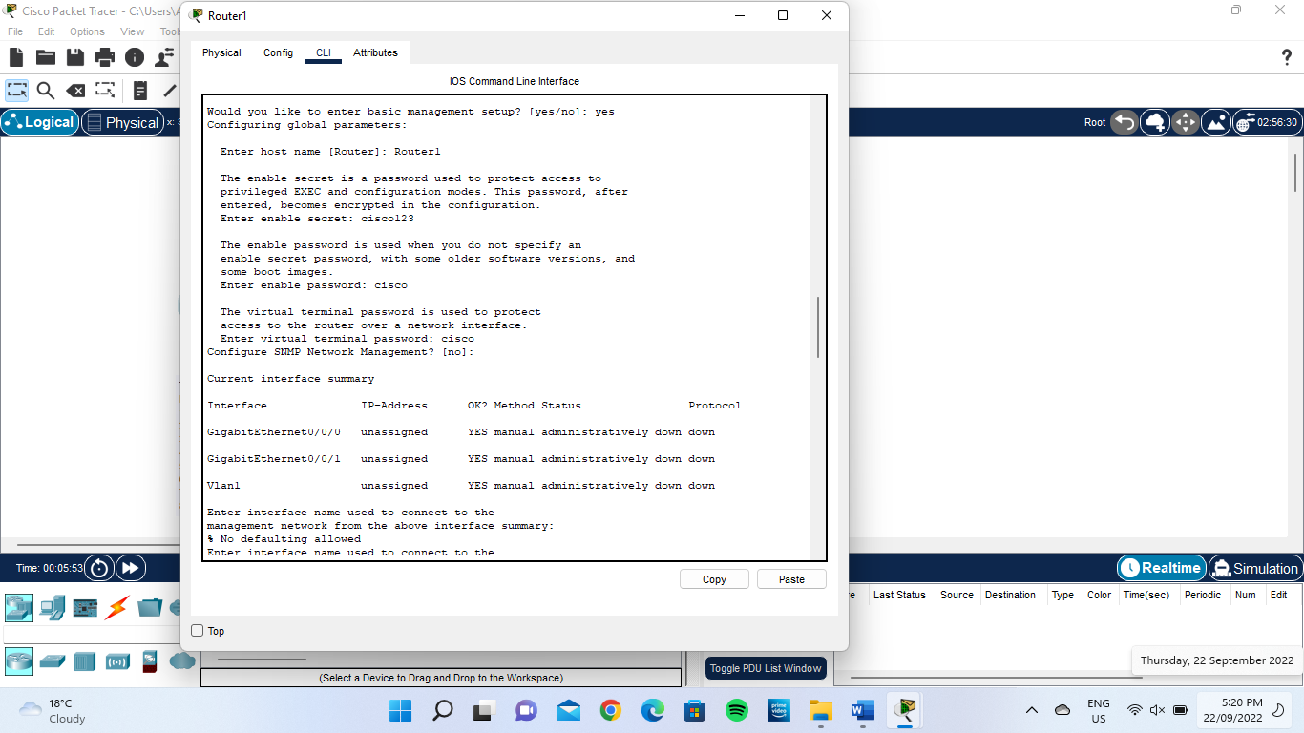

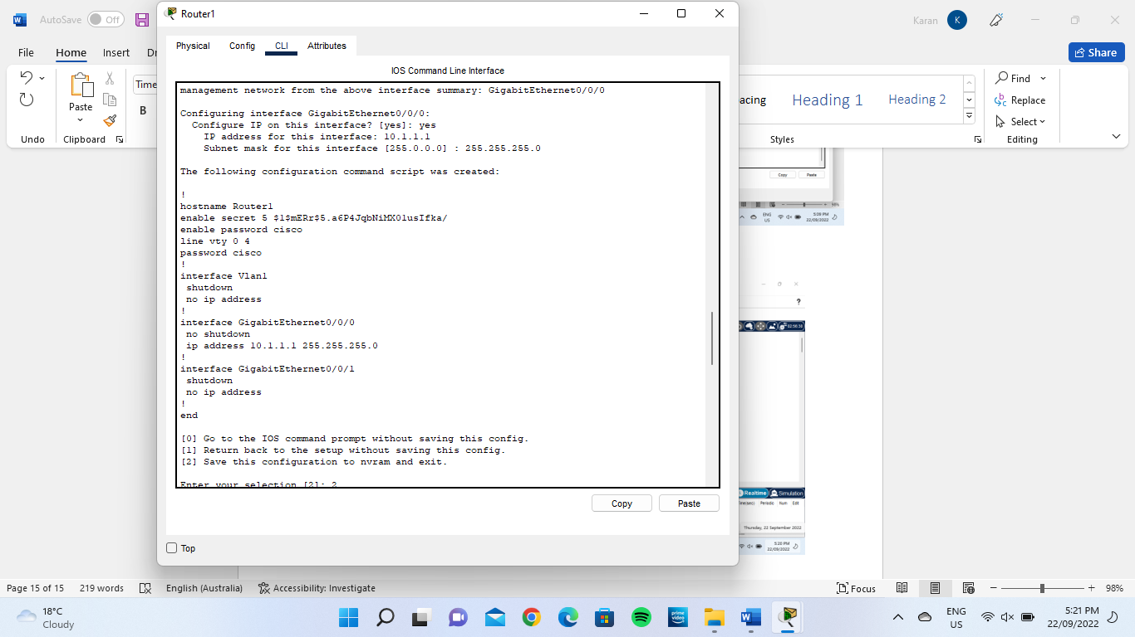

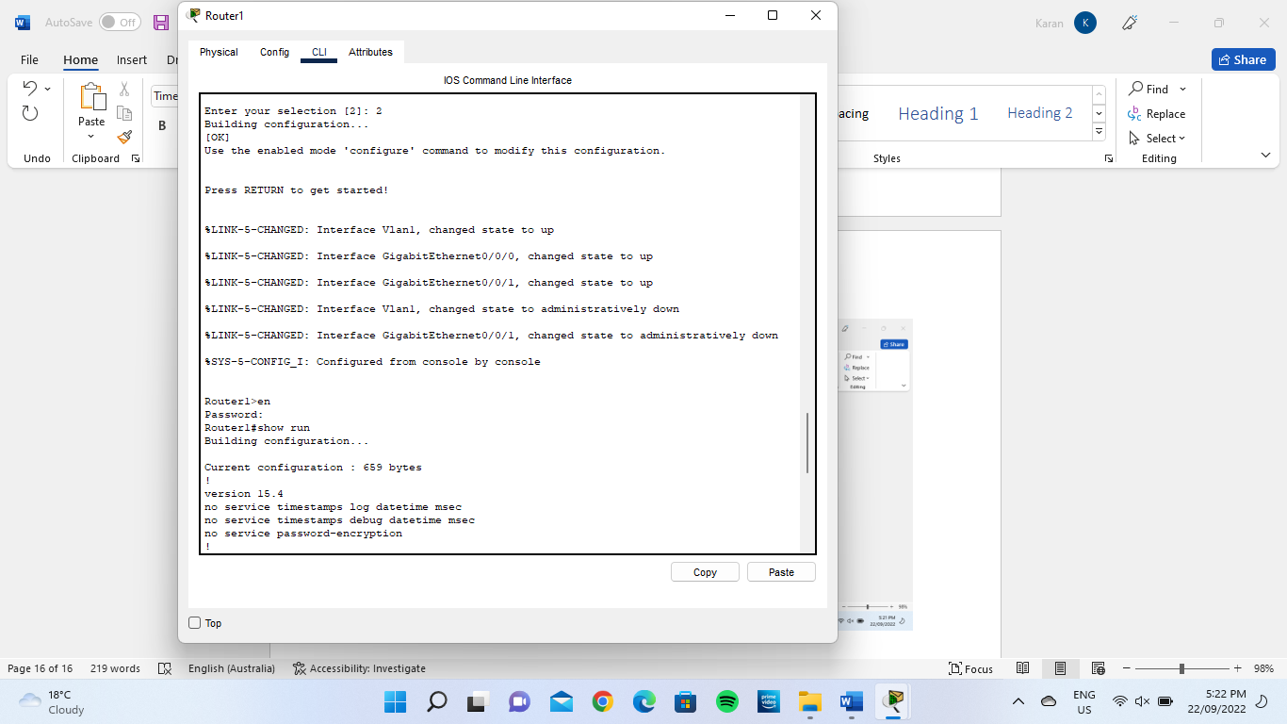

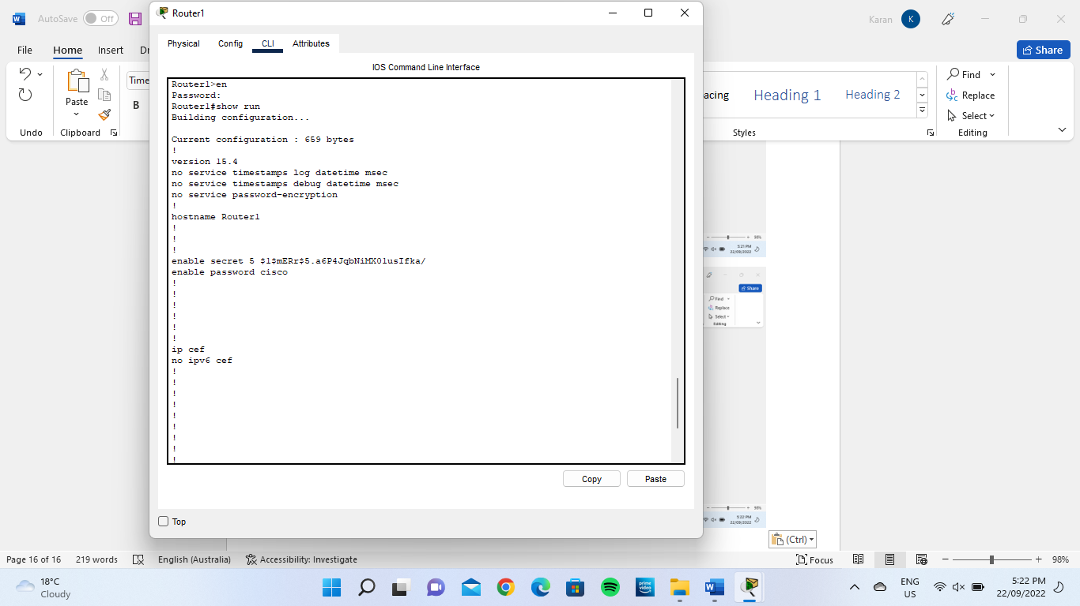

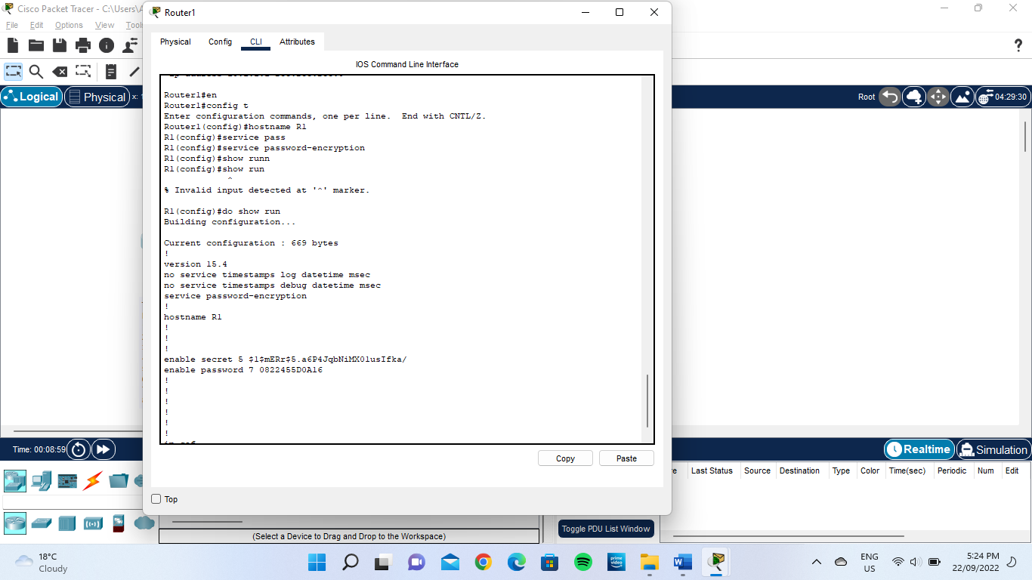

* **Compare running config and start-up config:**

When I change anything in configuration it will show in running configuration and nothing will change in startup configuration unless I copy running configuration into start-up configuration.

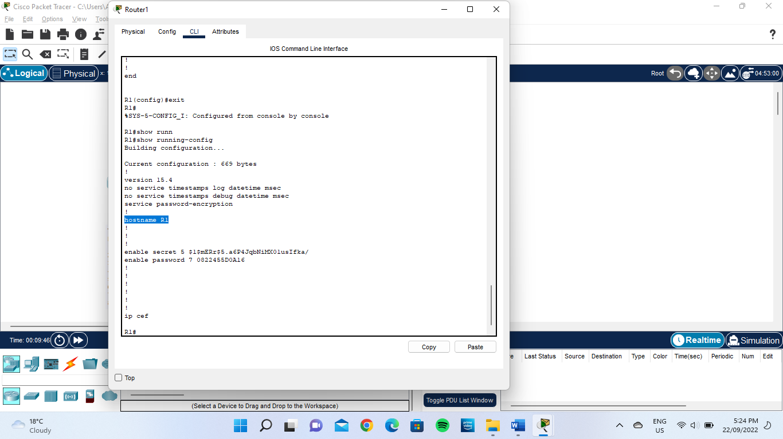

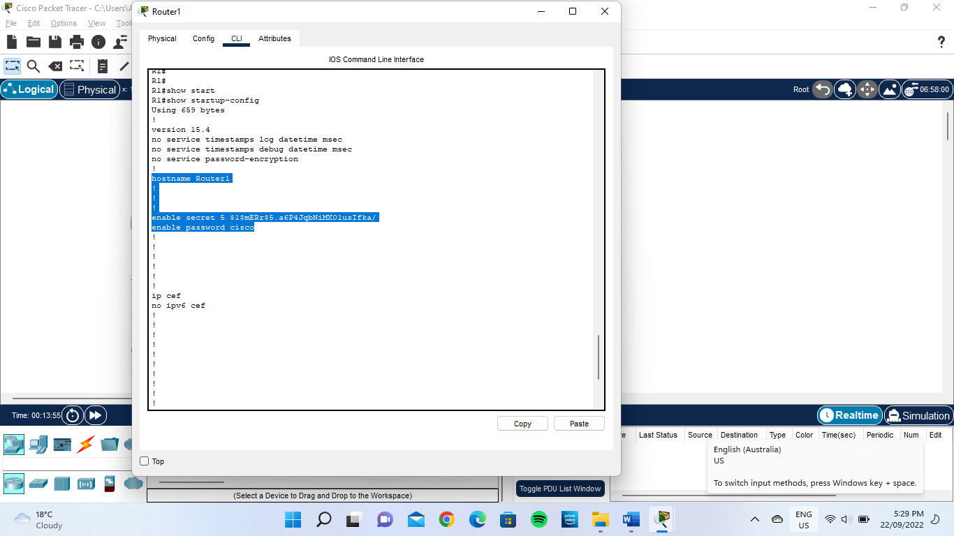

R1#copy running-config start

R1#copy running-config startup-config

Destination filename [startup-config]?

Building configuration...

[OK]

